**DESCRIPTION**

This guide provides the procedures for creating a provisioning package for a dispatch radio kiosk.

**GETTING STARTED**

**PROVISIONING PROCEDURES:**

1. Install Windows Imaging and Configuration Designer Build 1803.
2. Drag the working folder “Dispatch_Radio_KIOSK_Provisioning” to your local drive such as your Desktop. Open and command prompt and enter the following command: “SUBST X: Dispatch_Radio_KIOSK_Provisioning”. This allow you to run all scripts and create the provisioning package without the need to change any paths.

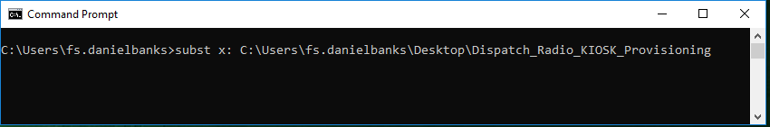

1. Ensure that all provisioning files are consolidate into the “X:\Combined_PKGs” folder. Please see Appendix A for a full list of files.
2. Create a .cab (Cabinet) file that contains all provisioning files by running the “CAB_Creation.bat” batch file. The batch file uses a PowerShell script that create the .CAB file.
3. Double-click the CAB_Creation.bat file. This script will take all files within the “X:\Combined_PKGs” folder and package them into a single .cab file.

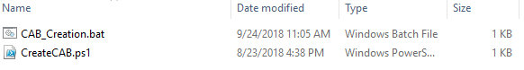

1. Verify that the .cab file has been created by navigating to the “X:\KioskProvisioningBatchWithCab” folder.

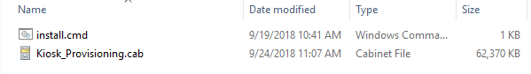

1. Create the provisioning package.
2. Launch Windows Imaging and Configuration Designer.

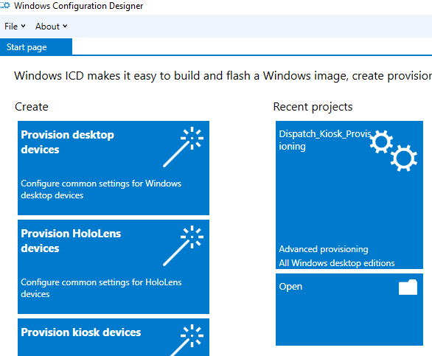

1. From the Start Page, Select Open and navigate to the “X:\Dispatch_Kiosk_Provisioning” folder and select the “Dispatch_Kiosk_Provisioning.icdproj.xml” file.

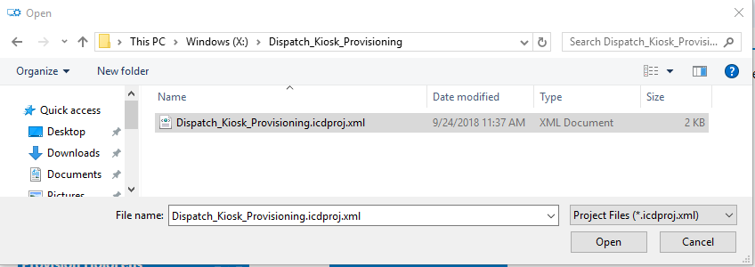

1. After opening the Dispatch_Kiosk_Provisioning project, expand the Runtime Setting and verify that the following three setting exist:

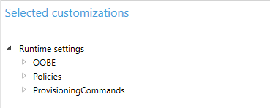

1. Expand the OOBE item and verify the following settings: (note: these setting should be already set)
2. **OOBE > Desktop > HideOobe** set to “TRUE”
3. **Policies > ApplicationManagement > AllowAllTrustedApps** set to “YES”
4. **ProvisioningCommands > DeviceContext > CommandFiles > install** set to “X:\KioskProvisioningBatchWithCab\install.cmd”
5. **ProvisioningCommands > DeviceContext > CommandFiles > Kiosk_Provisioning** set to “X:\KioskProvisioningBatchWithCab\Kiosk_Provisioning.cab”
6. **ProvisioningCommands > DeviceContext > CommandLine** set to “cmd /c start /max install.cmd”
7. Export the provisioning package to the “X:\Dispatch_Kiosk_Provisioning” folder.
8. Select the Export button in the Windows Image Configuration Designer from the upper left-hand corner of the main menu and select “Provisioning Package”.

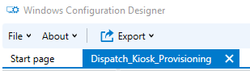

1. The Build windows appears with options to create the provisioning package.

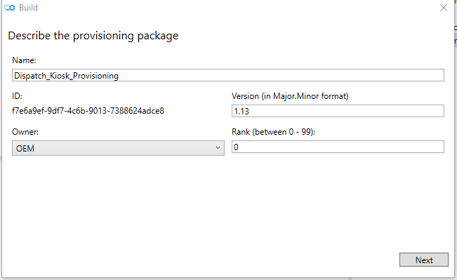

1. Click Next to advance to the Security screen. You can choose to encrypt the package and assign a certificate to the package.

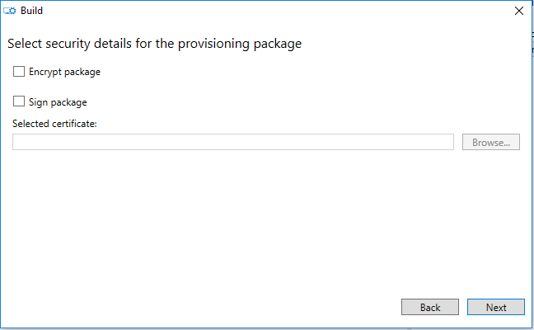

1. Select a location to create the provisioning package.

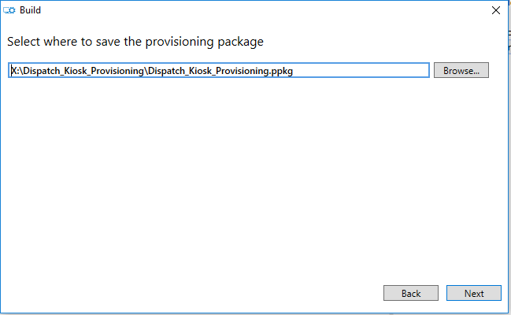

1. Click Build to create the provisioning package.

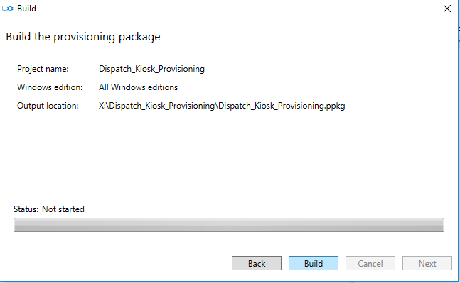

1. Click Finish. This complete the provisioning package creation.

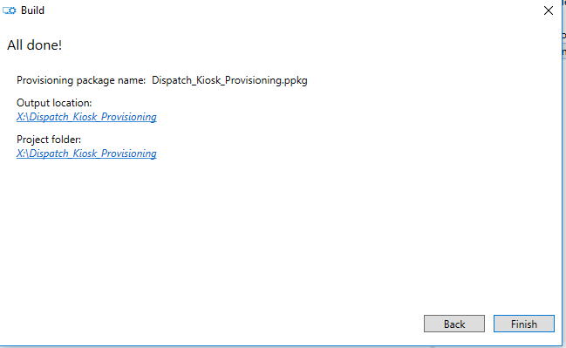

**APPENDIX A**

List of all associated provisioning files.

**\*\*\*Used by the provisioning package to initiate the provisioning process:**

1. Install.cmd (Unpacks the cabinet file to a temp folder and calls the OrchestratorScript.cmd)
2. Kiosk_Provisioning.cab

**\*\*\*Executes the Install.ps1 script and passes the Install.xml as parameter:**

1. OrchestratorScript.cmd

**\*\*\*Remove Lync Auto-Launch on Logon:**

1. RemoveLyncAutoRunRegistry.cmd
2. RemoveLyncAutoRunRegistry.vbs
3. RegUpdateAllHKCU64.vbs
4. Install.ps1 (single file used for multiple executables)
5. Install.xml (single file used for multiple executables)

**\*\*\*Installs Visual C++ 2005 x86:**

1. Visual_C_2005_x86.EXE
2. Install.ps1 (single file used for multiple executables)
3. Install.xml (single file used for multiple executables)

**\*\*\*Installs Visual C++ 2012 x86:**

1. Visual_C_2012_x86.EXE
2. Install.ps1 (single file used for multiple executables)
3. Install.xml (single file used for multiple executables)

**\*\*\*Copies all associated C-Soft files to their appropriate locations:** (See C-Soft application files below)

1. CopyC-SoftFiles.cmd
2. Install.ps1 (single file used for multiple executables)
3. Install.xml (single file used for multiple executables)

**\*\*\*Establishes C-Soft Runtime File Association:**

1. CSoftFileAssoc.cmd
2. Install.ps1 (single file used for multiple executables)
3. Install.xml (single file used for multiple executables)

**\*\*\*Cause the C-Soft application to prompt for default .veg file for every launch:**

1. RunRegUpdateDeleteDefaultVeg.cmd
2. DeleteDefaultVeg.cmd
3. RegUpdateDeleteDefault.vbs
4. Install.ps1 (single file used for multiple executables)
5. Install.xml (single file used for multiple executables)

**\*\*\*Adds the C-Soft Uninstaller to the Windows Programs and Features Control Panel:**

1. C-Soft_Uninstall.reg
2. Install.ps1 (single file used for multiple executables)
3. Install.xml (single file used for multiple executables)

**\*\*\*Install the Bosch Publishers certificate to the Trusted Publishers Store:**

1. bosch_publisher_cert.cer
2. Install.ps1 (single file used for multiple executables)
3. Install.xml (single file used for multiple executables)

**\*\*\*Installs the ADHB-4 Driver set:**

1. dpinst.exe
2. dpinst.xml
3. Install.ps1 (single file used for multiple executables)
4. Install.xml (single file used for multiple executables)

**\*\*\*Installs the Telex Licensing Server:**

1. TelexLicenseServer-x86-1.2.0.0.exe
2. Install.ps1 (single file used for multiple executables)
3. Install.xml (single file used for multiple executables)

**\*\*\*Create the local kiosk account:**

1. CreateLocalAccount.ps1
2. Install.ps1 (single file used for multiple executables)
3. Install.xml (single file used for multiple executables)

**\*\*\*Creates the custom shells for both the kiosk account and all admin accounts:**

1. ShellLauncherConfig.ps1
2. Install.ps1 (single file used for multiple executables)
3. Install.xml (single file used for multiple executables)

**\*\*\*Creates Auto-logon for the kiosk account:**

1. LocalAutoLogonRegedit.ps1
2. Install.ps1 (single file used for multiple executables)
3. Install.xml (single file used for multiple executables)

**\*\*\*Restarts the computer after provisioning process completes:**

1. RestartComputer.ps1
2. Install.ps1 (single file used for multiple executables)
3. Install.xml (single file used for multiple executables)

**\*\*\*C-Soft application files:**

1. 1 Tornado Alert.wav
2. 10 Shelter All Clear.wav
3. 11 Shelter Test.wav
4. 12 Shelter Test Complete.wav
5. 2 Tornado All Clear.wav
6. 3 Tornado Test.wav
7. 4 Tornado Test Complete.wav
8. 5 Lightning.wav
9. 511.bmp
10. 588Mall_Final3 750_480vss.bmp
11. 6 Lightning All Clear.wav
12. 7 Lightning Test.wav
13. 759_Airport_2_1 1000_800.bmp
14. 8 Lightning Test Complete.wav
15. 9 Shelter.wav
16. 911.bmp
17. abort.bmp
18. adhb-4.cat
19. ADHB-4.inf
20. ADHB4_Default.veg
21. adm_1.bmp
22. AIS Sample.veg
23. alarm_bell.bmp
24. Alert.wav
25. alerts red.bmp
26. alerts.bmp
27. Alerts1.bmp
28. all units.wav
29. AMBE+2_pwplugin.dll
30. AMBERX.bmp
31. AMBERXs.bmp
32. API_Demo-SystemList.xml
33. API_Demo.veg
34. areacode.bmp
35. arrow1.bmp
36. Aurora.bmp
37. BADGE-L.bmp
38. BADGE-S.bmp
39. BADGE2-L.bmp
40. BADGE2-S.bmp
41. BADGE3-L.bmp
42. BADGE3-S.bmp
43. BADGE4-L.bmp
44. BADGE4-S.bmp
45. BADGE4-XL.bmp
46. BADGE5-L.bmp
47. BADGE5-S.bmp
48. BADGE6-L.bmp
49. BADGE6-S.bmp
50. BeepHigh.bmp
51. BeepMute.bmp
52. BeepMute1.bmp
53. blkgry.bmp
54. bolt.bmp
55. Bosch.Operational.dll
56. Bosch.Security.UserManagementService.ActivationLib.dll
57. Bosch.Security.UserManagementService.ActivationLib_libFNP.dll
58. Bosch.UserInterfaces.Mvvm.dll
59. BOSCHST.exe
60. BOSCHST.opt
61. BOSCHST_libFNP.dll
62. BOSCHST_LicMgr.lic
63. C-Soft Designer.lnk
64. C-Soft Runtime.lnk
65. C-Soft Sample Files.lnk
66. CallHistory.bmp
67. Camera-icon sm.bmp
68. cdm_1.bmp
69. cdm_2.bmp
70. College Campus.bmp
71. Contacts.bmp
72. CSOFT-L.bmp
73. CSOFT-S.bmp
74. CSoftDesigner.exe
75. csoftruntime.exe
76. csoftruntime_libFNP.dll
77. daniels.bmp
78. Default_SIP.veg
79. DFSI_Danels_Test-SystemList.xml
80. DFSI_Daniels_Test.veg
81. DFSI_Server_Example-SystemList.xml
82. DFSI_Server_Example.veg
83. DHS-1.bmp
84. DHS-med.bmp
85. DHS-sml.bmp
86. DHS-xl.bmp
87. DHS.bmp
88. door.bmp
89. dpinst.exe
90. dpinst.xml
91. elite_126 new.bmp
92. elite_126.bmp
93. elite_127.bmp
94. elite_128.bmp
95. elite_1_127.bmp
96. elite_520.bmp
97. Emer Clear Red.bmp
98. Emer Clear.bmp
99. Emer Tones Red.bmp
100. Emer Tones.bmp
101. Emergency.bmp
102. Emergency1.bmp
103. EMT-L.bmp
104. EMT-S.bmp
105. EMT-XL.bmp
106. EMT2-LX.bmp
107. EMT2-S.bmp
108. EMT2-X.bmp
109. EMT3-L.bmp
110. EMT3-S.bmp
111. EMT3-XL.bmp
112. EMT4-L.bmp
113. EMT4-S.bmp
114. EPA.bmp
115. Example3.veg
116. exchange.bmp
117. FAA.bmp
118. FBI.bmp
119. fire Z1 F1.wav
120. fire Z1 F3.wav
121. fire Z3 F1.wav
122. FIRE-L.bmp
123. FIRE-S.bmp
124. FIRE-XL.bmp
125. FleetSyncSystemList.xml
126. FleetSync_Default.veg
127. FNP_Act_Installer.dll
128. green-check2.bmp
129. group page.bmp
130. hazmat.bmp
131. Headset-L.bmp
132. Headset-S.bmp
133. HH-L.bmp
134. HH-S.bmp
135. HH-XL.bmp
136. icled.bmp
137. input dwn.BMP
138. input up.BMP
139. installanchorservice.exe
140. installs.exe
141. intercom tx.bmp
142. intercom tx2.bmp
143. intercom.bmp
144. intu Loading Z2.wav
145. intu main gnd fl.wav
146. IP223-L.bmp
147. IP223-S.bmp
148. LA CTNY.bmp
149. libeay32.dll
150. lmgrd.exe
151. lmreread.exe
152. Master PTT up.bmp
153. Master PTT.bmp
154. MDC-1200_Default.veg
155. MDC_Demo.xml
156. mic down.bmp
157. mic.bmp
158. monitor down.bmp
159. monitor.bmp
160. Mototrbo_Default.veg
161. Mototrbo_Default.xml
162. multi sel tx red.bmp
163. multi sel TX.bmp
164. Muppet-Beaker[1].bmp
165. NEO10_L.bmp
166. NEO10_S.bmp
167. NEXEDGE IP Interface Demo.veg
168. NEXEDGE IP Interface Demo.xml
169. NEXTEL.bmp
170. nexusIP Logo.bmp
171. nws.bmp
172. NXDN.bmp
173. outerspacevenus.bmp
174. P25_Radio.bmp
175. page.bmp
176. Pages.bmp
177. PASP.bmp
178. patch 1 TX red.bmp
179. patch 1 TX.bmp
180. patch 2 TX red.bmp
181. patch 2 TX.bmp
182. patch 2.bmp
183. patch 2a.bmp
184. patch 3 TX red.bmp
185. patch 3 TX.bmp
186. Patch 3.bmp
187. patch TX reda.bmp
188. patch TX.bmp
189. patch TXa.bmp
190. Patch.bmp
191. patch1.bmp
192. Penguin.veg
193. PFDD.bmp
194. PFDU.bmp
195. PH hold.BMP
196. PH offhk.BMP
197. PH onhk-1.bmp
198. PH onhk.BMP
199. PHONED.bmp
200. PHONEU.bmp
201. Play.bmp
202. power plant C.bmp
203. power1-L - Copy.bmp
204. power1-L.bmp
205. power1-S - Copy.bmp
206. power1-S.bmp
207. power1-XL - Copy.bmp
208. power1-XL.bmp
209. power2-L - Copy.bmp
210. power2-L.bmp
211. power2-S.bmp
212. power2-XL.bmp
213. PPD.bmp
214. ptt.bmp
215. ptt1.bmp
216. Radio Dispatch Solutions.bmp
217. Readme.txt
218. red_x_mark2.bmp
219. rxled.bmp
220. rxled1.bmp
221. scan off.BMP
222. scan on.BMP
223. send page.bmp
224. SPRINT.bmp
225. sup dwn.BMP
226. sup up.BMP
227. TB9100.bmp
228. TB9100b.bmp
229. Telex Test Lab.veg
230. telex.bmp
231. telexIcon.ico
232. TLXVOIP2.bmp
233. tone.wav
234. tone2.wav
235. tone3.wav
236. tool bar cop.bmp
237. tool bar cop1.bmp
238. Tools.bmp
239. Transparent.bmp
240. txled.bmp
241. unins000.dat
242. unins000.exe
243. uninstallanchorservice.exe
244. unmute.bmp
245. uscg.bmp
246. VOIProven50-1.bmp
247. VOIProven50.bmp
248. WdfCoInstaller01007.dll
249. white pages.bmp
250. WinUSBCoInstaller.dll